**Name – Parag Gattani**

Program No. – 04

Program Title – LED fading with potentiometer

**AIM**

Demonstrate to show LED fading(analog output).

**HARDWARES REQUIRED**

* Arduino Board
* LED bulb
* Potentiometer

**CIRCUIT DIAGRAM**

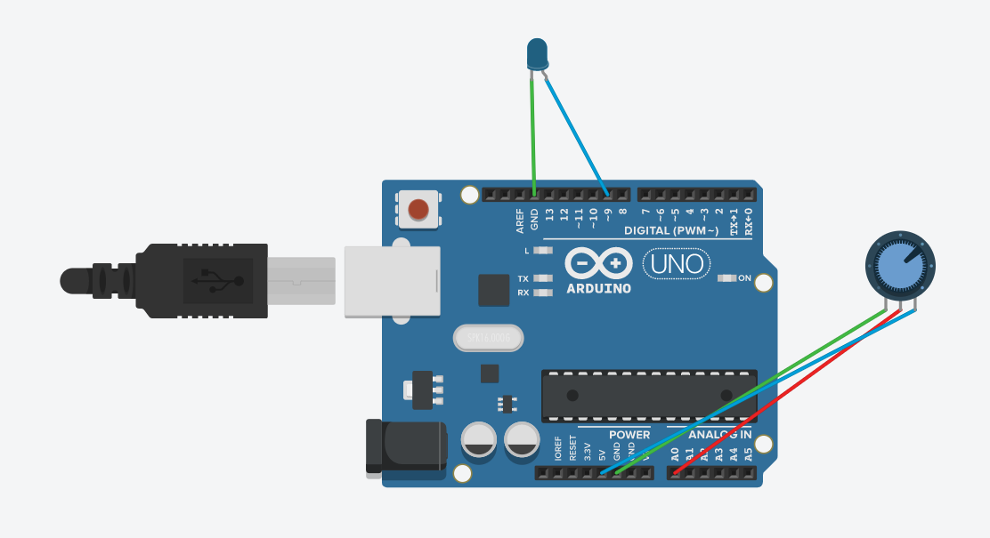

**WRITE-UP**

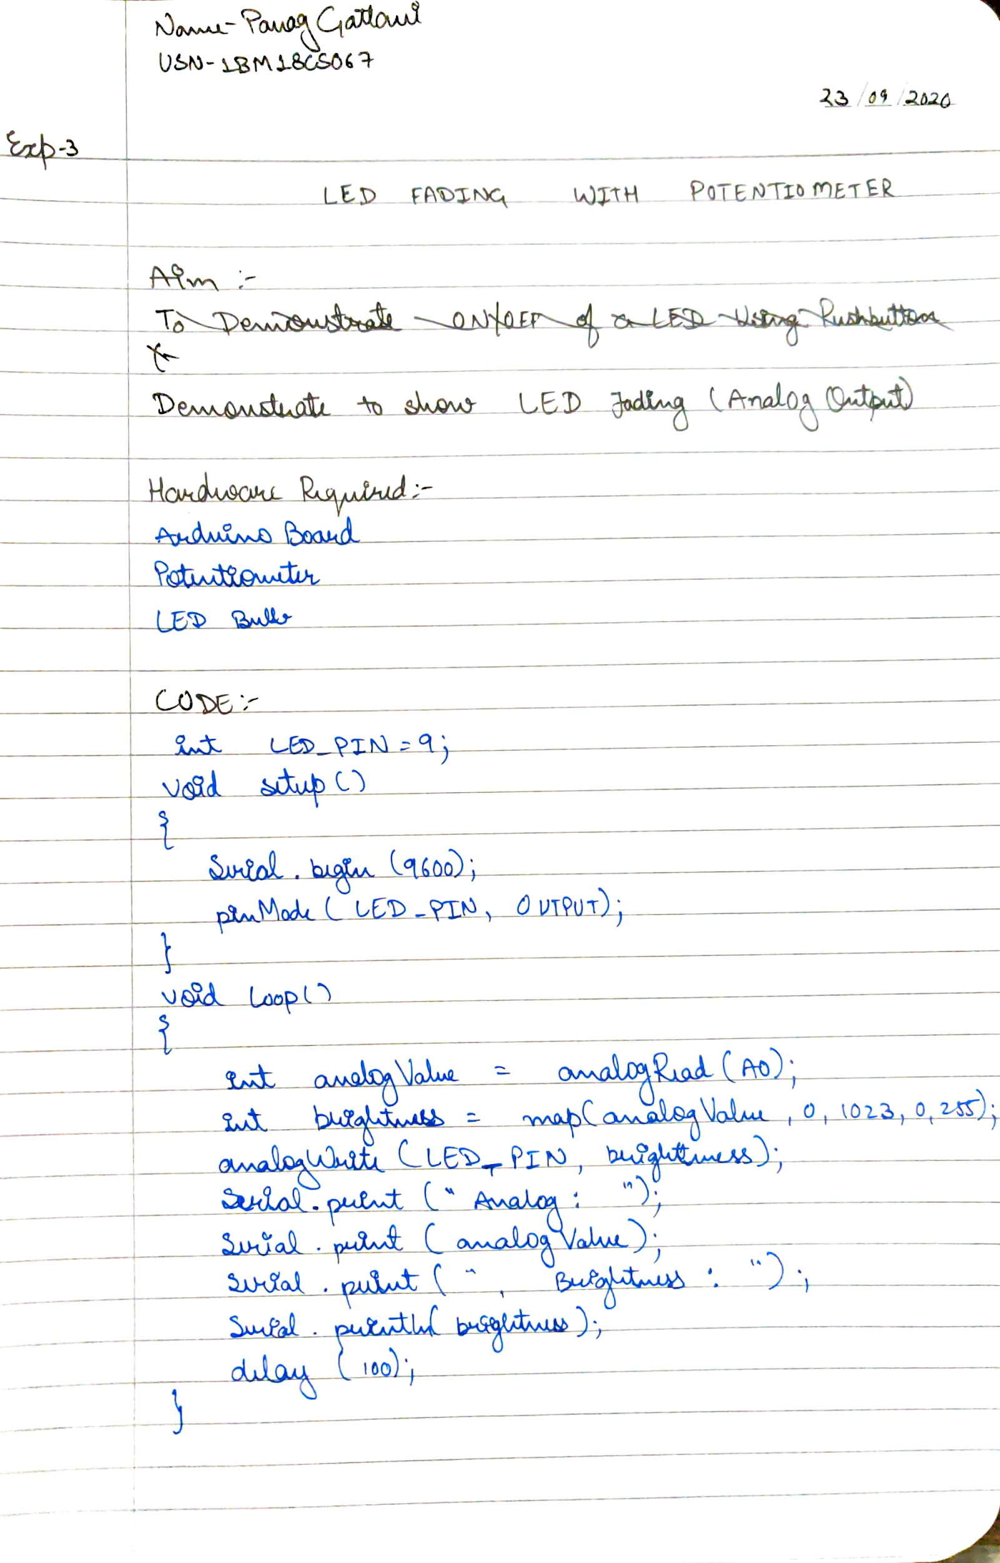

**CODE**

int LED_PIN = 9;

void setup()

{

Serial.begin(9600);

pinMode(LED_PIN, OUTPUT);

}

void loop()

{

int analogValue = analogRead(A0);

int brightness = map(analogValue, 0, 1023, 0, 255);

analogWrite(LED_PIN, brightness);

Serial.print("Analog: ");

Serial.print(analogValue);

Serial.print(", Brightness : ");

Serial.println(brightness);

delay(100);

}

**OUTPUT**

Fading of LED with potentiometer.